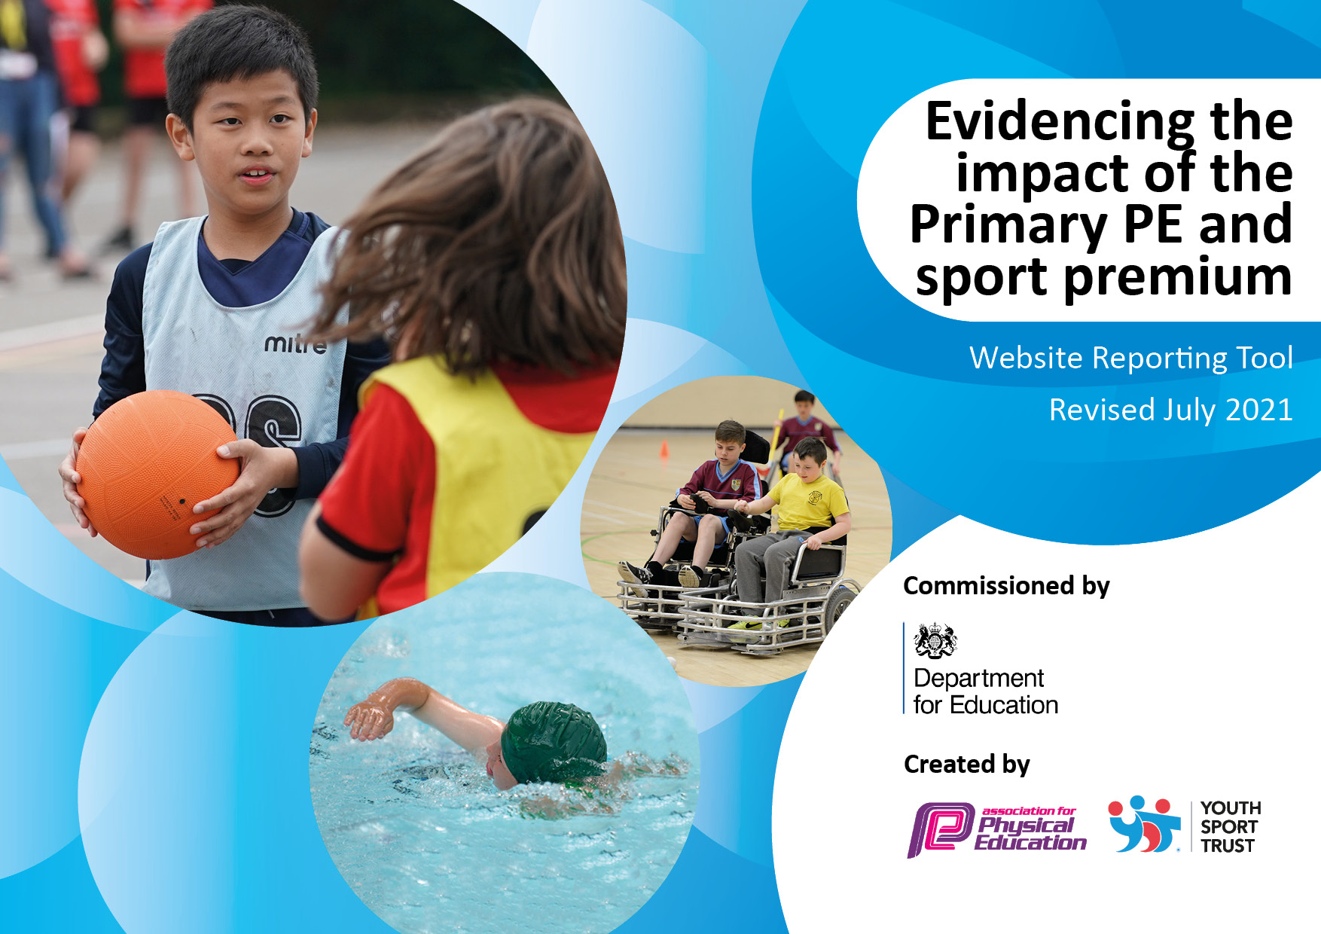
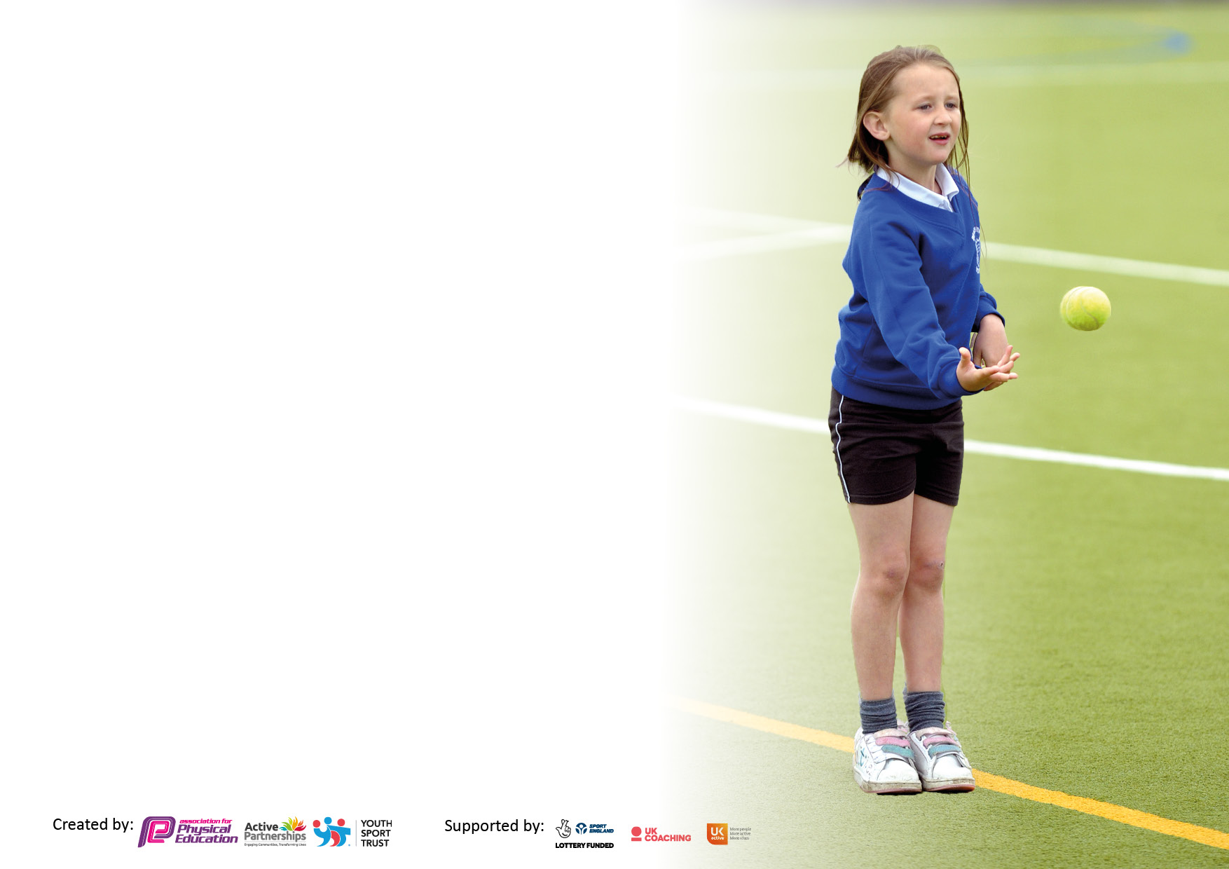

It is important that your grant is used effectively and based on school need. The Education Inspection Framework makes clear there will be a focus on ‘whether leaders and those responsible for governors all understand their respective roles and perform these in a way that enhances the effectiveness of the school’.

Under the Quality of Education Ofsted inspectors consider:
Intent - Curriculum design, coverage and appropriateness
Implementation - Curriculum delivery, Teaching (pedagogy) and Assessment
Impact - Attainment and progress

To assist schools with common transferable language this template has been developed to utilise the same three headings which should make your plans easily transferable between working documents.

Schools must use the funding to make additional and sustainable improvements to the quality of Physical Education, School Sport and Physical Activity (PESSPA) they offer. This means that you should use the Primary PE and sport premium to:

- Develop or add to the PESSPA activities that your school already offer
- Build capacity and capability within the school to ensure that improvements made now will benefit pupils joining the school in future years
- The Primary PE and sport premium should not be used to fund capital spend projects; the school’s budget should fund these.

Pleasevisitgov.ukfortherevisedDfEguidanceincludingthe5keyindicatorsacrosswhichschoolsshoulddemonstrate animprovement.Thisdocumentwillhelpyoutoreviewyourprovisionandtoreportyourspend.DfEencouragesschools to use this template as an effective way of meeting the reporting requirements of the Primary PE and sport premium.

We recommend you start by reflecting on the impact of current provision and reviewing the previous spend.

Schools are required to publish details of how they spend this funding, including any under-spend from 2019/2020, as well as on the impact it has on pupils’ PE and sport participation and attainment. All funding must be spent by 31st July 2022.

We recommend regularly updating the table and publishing it on your website throughout the year. This evidences your ongoing self-evaluation of how you are using the funding to secure maximum, sustainable impact. Final copy must be posted on your website by the end of the academic year and no later than the 31st July 2021. To see an example of how to complete the table please click HERE.
Created by: Supported by:

Details with regard to funding
Please complete the table below.

Total amount carried over from 2020/21 | £3,800
Total amount allocated for 2021/22 | £17,200
How much (if any) do you intend to carry over from this total fund into 2022/23? | £6,000
Total amount allocated for 2022/23 | £15,000
Total amount of funding for 2022/23. To be spent and reported on by 31st July 2023. | £21,000
Swimming Data
Please report on your Swimming Data below.

What percentage of your current Year 6 cohort swim competently, confidently and proficiently over a distance of at least 25 metres?  N.B. Even though your pupils may swim in another year please report on their attainment on leaving primary school at the end of the summer term 2021.  Please see note above | 82%  14/17
What percentage of your current Year 6 cohort use a range of strokes effectively [for example, front crawl, backstroke and breaststroke]?  Please see note above | 76%
What percentage of your current Year 6 cohort perform safe self-rescue in different water-based situations? | 71%
Schools can choose to use the Primary PE and sport premium to provide additional provision for swimming but this must be for activity over and above the national curriculum requirements. Have you used it in this way? | No – Unable to deliver additional sessions due to pool closure

Academic Year: 2022/ 2023 | Total fund allocated: £15,000 | Date Updated: October 2022
Key indicator 1: The engagement of all pupils in regular physical activity – Chief Medical Officers guidelines recommend that primary school pupils undertake at least 30 minutes of physical activity a day in school |  |  |  | Percentage of total allocation:
 |  |  |  | 51%
Intent | Implementation |  | Impact
Children will be actively involved in organised games and physical activity at break and lunch time | A range of new resources will be purchased for break and lunchtime play. These will be organised and distributed by Playground Leaders. There will be a member of SLT on duty each lunch to model co-operative and active play. | £2,000 |  | Children will be trained and developed as playground leaders. This opportunity will not only develop children’s leadership skills but will also ensure encourage others to become involved, ensuring the initiative is sustained.
Purposeful play will be promoted at break and at lunch times. | In-house training for lunch time and playtime staff on:  Clapping games and rhymes  Skipping rhymes  Starting a new craze  Ball games  - Purchase relevant resources | £500 for staff training and  £200 for resources |  | Senior leaders will be on duty to support and develop this intent, so that it is embedded.
The Daily Mile will be introduced as a strategy to provide additional physical activity. | There will be a planned route for all children. The Daily Mile will be timetabled, collaborating younger children with their older peers. The timetable slots will be appropriately staffed, who will also participate in the initiative, promoting a whole school approach. | £5,000 |  | This initiative will be funded so that the route for the Daily Mile is a permanent part of the academy grounds, ensuring this can continue in future years without any financial implication.
All children will be able to swim confidently and proficiently over a distance of at least 25 metres. | Additional swimming lessons - For those children in the current Year Five, who completed the allocated lessons and who are still not meeting this milestone. | £1,800
Key indicator 2: The profile of PESSPA being raised across the school as a tool for whole school improvement |  |  |  | Percentage of total allocation:
 |  |  |  | 10%
Intent | Implementation |  | Impact
Develop stakeholders’ understanding of PESSPA and the positive impact this has on the lives of Marshland children. | There will be regular CPD opportunities for the PE Subject Leader, who will report to parents and governors on PESSPA.  Developing leadership, will also involve training all staff on their understanding of the impact of PESSPA. | £1,500 |  | Developing subject leadership of PESSPA will ensure that children access high quality opportunities as part of academy life, with limited support from external partnerships.
PESSPA will be integral to academy life. | Opportunities for any physical education, school sports and physical activity will be shared in newsletters, on Twitter and in the local press. | £0

Key indicator 3: Increased confidence, knowledge and skills of all staff in teaching PE and sport |  |  |  | Percentage of total allocation:
 |  |  |  | 7%
Intent | Implementation |  | Impact
Ensure the leadership of the teaching and learning in PE is embedded in the academy development plan. | Identify leadership as a whole school priority and embed opportunities for quality assurance and monitoring activities in to the academy’s school improvement cycle. | £1,000 |  | Developing subject leadership of PE will ensure the teaching and learning of PE continues to improve
Key indicator 4: Broader experience of a range of sports and activities offered to all pupils |  |  |  | Percentage of total allocation:
 |  |  |  | 39%
Intent | Implementation |  | Impact
There will be a range of clubs available for all children. | All clubs will be resourced appropriately and children will access different sports to those planned in the curriculum.  Thursday afternoon club, will be an opportunity for children to attend additional sports clubs. | £1,000  resources  £760  Club Doncaster  £1140  Staffing |  | Carry out pupil voice so that children are leading decisions about the clubs that they would like to attend.
Throughout the holidays, children will be able to access sports clubs. | For six weeks Club Doncaster will run sports clubs in the school. This will provide the children with access to holiday provision for sports and activities linked to maintaining a physical and healthy lifestyle. | £3,000 |  | Survey parents to ensure provision is effective and supporting the community’s needs.

Key indicator 5: Increased participation in competitive sport |  |  |  | Percentage of total allocation:
 |  |  |  | %
Intent | Implementation |  | Impact
Children will participate in more sporting competitions. | Make sure your actions to | Funding | Evidence of impact: what do | Sustainability and suggested
what you want the pupils to know | achieve are linked to your | allocated: | pupils now know and what | next steps:
and be able to do and about | intentions: |  | can they now do? What has
what they need to learn and to |  |  | changed?:
consolidate through practice:

Signed off by
Head Teacher: | Mrs Sarah Hall
Date: | October 2022
Subject Leader: | Miss Sue Gardiner
Date: | September 2022
Governor: | Mr Martin Oldknow
Date: | October 2022

