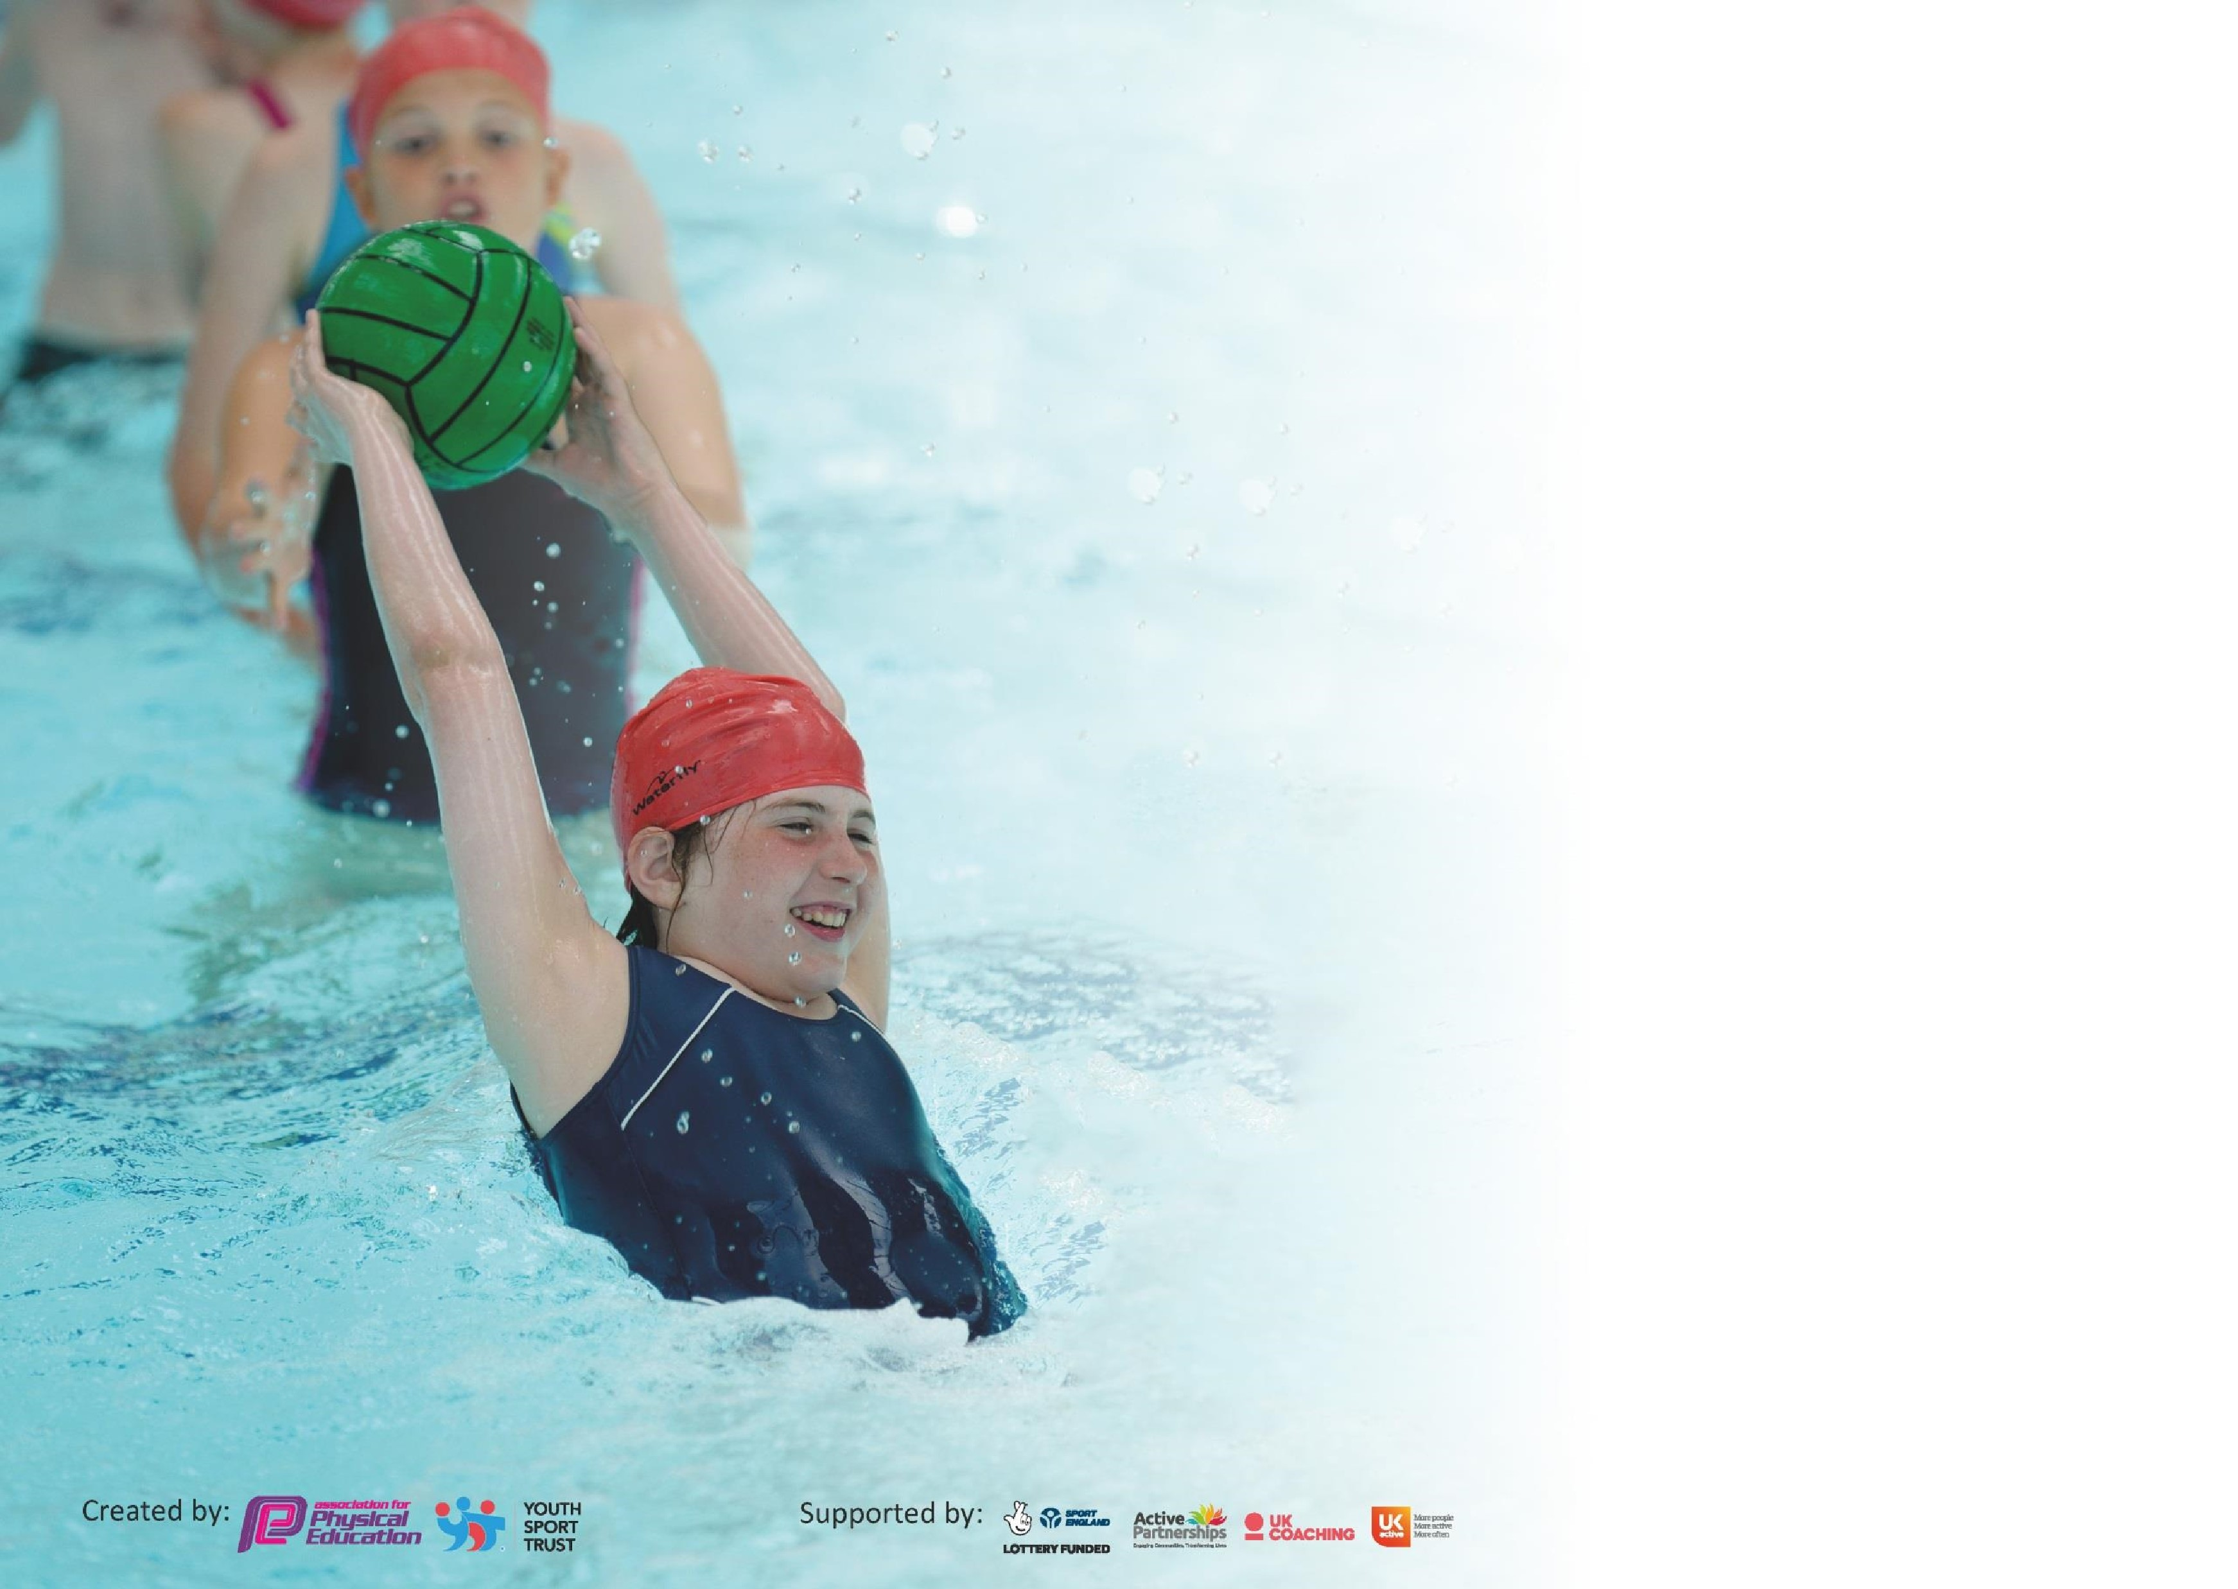

It is important that your grant is used effectively and based on school need. The
Education Inspection Framewor
k

(
Ofsted 2019 p64) makes clear there will be a focus on
‘whethe
r leaders and those responsible for governors all
understand their respective roles and perform these in a way that enhances the effectiveness of the school’
.

Under

the

Qualit
y

o
f

Educatio
n

criteri
a

(
p41)

inspectors

consider

the

extent

to

which

schools

can

articulate
their curriculum (INTENT), construct their curriculum
(
IMPLEMENTATION)
and demonstrate the outcomes
which result

(
IMPACT
).

To assist schools with common transferable language this template has been developed to utilise the same
three headings w
hich should make your plans easily transferable between working documents.

Schools must use the funding to make
additional and sustainable
improvements to the quality of
Physical Education, School Sport and Physical Activity

(
PESSPA)
they
offer.
This
means that you should

use the Primary PE and Sport Premium to:

•

Develop or add to the
PESSPA
activities that your school already

offer

•

Build capacity and capability within the school to ensure that improvements made now

will
benefit pupils joining the
school in future

years

Please visit
gov.u
k

f
or the revised DfE guidance including the 5 key indicators across which
schools should demonstrate an improvement. This doc
ument will help you to review your
provision and to report your spend. DfE encourages schools to use this template as an
effective way of meeting the reporting requirements of the Primary PE and Sport Premium.

We recommend you start by reflecting on the i
mpact of current provision and reviewing the
previous spend.

Schools are required to
publish detail
s

o
f how they spend

this funding as well as on the
impact it has on pupils’ PE and sport participation and attainment by the end of the
summer term or by
31
st
July 2022
22

at the latest.

We recommend regularly updating the table and publishing it on
your website
throughout the year. This evidences your ongoing self
-
evaluation of how you are
using the funding to secure maximum, sustainable impact. Final copy must be
posted on your website by the end of the academic year and no later than the
31
st July
20222
22
. To see an example of how to complete the table please click
HER
E
.

Support for review and reflection - considering the 5 key indicators from DfE, what development needs are a priority for your setting and your pupils now and why? Use the space below to reflect on previous spend and key achievements and areas for development.
Meeting national curriculum requirements for swimming and water safety. Data estimated - Cancellation of some swimming lessons due to lockdown | 75%  (12 out of 16 children)
What percentage of your current Year 6 cohort swim competently, confidently and proficiently over a distance of at least 25 metres?  N.B. Even though your pupils may swim in another year please report on their attainment on leaving primary school at the end of the summer term 2020. | 75%
What percentage of your current Year 6 cohort use a range of strokes effectively [for example, front crawl, backstroke and breaststroke]? | 69%

Key achievements to date until July 2022: | Areas for further improvement and baseline evidence of need:
- There continues to be a successful dance club at lunch time, attended by girls and boys. These culminated in a concert for parents.  - There are a number of sports clubs for children of all ages to attend.  - Children have been trained to be Playground Leaders and this has led to younger children being actively involved in playing games at playtime.  - Working with the Club Doncaster has proven to be very successful with children participating in a wider range of sports  - The children have had the opportunity to attend a holiday club for six weeks spread across the year; the focus of these clubs has been sports and healthy lifestyle. | - To improve children’s access to regular physical activity by introducing the Daily Mile.  - To provide opportunities for children to access a range of different sports in addition to those taught in the Physical Education Curriculum.  - To train a different set of Playground Leaders to develop leadership skill in our older children and to develop physical play with our younger children.  - To collaborate with Club Doncaster and train new playground buddies in Year 6.  - To provide a half term club at the school to promote sports and healthy living as well as offer childcare  - To provide an after-school club that offers a range of sports to promote different sports to our pupils.  - To provide extra swimming lessons for those children in Year 6 who have not reached national expectations

What percentage of your current Year 6 cohort perform safe self-rescue in different water-based situations? | 50%
Schools can choose to use the Primary PE and Sport Premium to provide additional provision for swimming but this must be for activity over and above the national curriculum requirements. Have you used it in this way? | No – organising additional lessons has been difficult as the local pool is closed for refurbishment.

Action Plan and Budget Tracking
Capture your intended annual spend against the 5 key indicators. Clarify the success criteria and evidence of impact that you intend to measure to evaluate for pupils today and for the future.

Academic Year: 2020/21 | Total fund allocated: £ | Date Updated:
Key indicator 1: The engagement of all pupils in regular physical activity – Chief Medical Officer guidelines recommend that primary school pupils undertake at least 30 minutes of physical activity a day in school |  |  |  | Percentage of total allocation:
 |  |  |  | %
Intent | Implementation |  | Impact
Promote more active and creative play during play times and lunch times. | In-house training for lunch time and playtime staff on:  Clapping games and rhymes  Skipping rhymes  Starting a new craze  Ball games  Purchase relevant resources | £1,500 | Children have access to a number of additional clubs at breaktime. As training has not been able to go ahead, this intent has been supported through the purchase of additional play equipment. | 100
Provide swimming lessons for Y6 pupils who did not achieve 25 metres in Y5. | All pupils who are not able to swim  25 in Y5 will be given the opportunity to swim in Y6. | £1,800 | Due to the closure of the swimming pool throughout lockdown, this intent did not happen. | 0
Introduce tracking of pupils to enable support for those less active. | Teachers deliver their own PE lessons using the new scheme of work and train them to assess their pupils using the assessment tool for tracking progress in PE. | £500 | All PE lessons are supported by unit plans that sequence learning within a unit and across the year groups. Teachers are beginning to assess children’s PE abilities | 100
Encourage children to be active  during break and lunchtimes | Club Doncaster to be utilised to train pupils as playground leaders to ensure a wide range of physical activities are available on the playground. Sporting equipment to be sourced. | £1000 | Playground leaders were in place and their games were resourced. The team of children had appropriate training through Club Doncaster. | 100

Offer a Sports Club during one school holiday on the school grounds | Utilise Club Doncaster to run a sports club for one week in the October term for approx. 40 pupils. Places offered on a first come, first served basis | £1000 | This took place during two holidays, with an additional cost of £200. The club was attended by 25 children during the first session and 40 during the second. More children are accessing sports clubs during holiday periods. | 120
Create an extra 15mins active session into the school day | Within their class bubble, teachers lead an extra 15 mins session of physical activity for all children. | None | When children returned after lockdown, all children accessed additional physical activity breaks to increase active sessions. | na
Access physical activity sessions during breakfast club | Reintroduce resources and a member of staff to deliver short sessions for children during autumn term. | £1,500 | Club Doncaster provided breakfast club physical activity sessions on two days per week. Approx. 50% of KS2 children attended and as well as additional active sessions, this also supported priority to improve children’s behaviour and attitudes to learning, as they started lessons following a breakfast and short physical activity session. | 100
Provide an after-school club for six half terms | Each half term the club will offer a  different sport  This club will be run by Club  Doncaster  Places offered on a first come first served basis | £1900 | Clubs took place and children engaged well. More Marshland children were accessing extra-curricular sporting activities. | 67
Key indicator 2: The profile of PESSPA being raised across the school as a tool for whole school improvement |  |  |  | Percentage of total allocation:
 |  |  |  | %
Intent | Implementation |  | Impact
Raise profile of individual’s attainment in PE lessons | Children to receive PE Pupil of the Week in Celebration Assembly each week and photographs of pupils shared on social media. | Nil | This did not continue as an intent due to lockdown. | na

Key indicator 3: Increased confidence, knowledge and skills of all staff in teaching PE and s |  |  | port | Percentage of total allocation:
 |  |  |  | %
Intent | Implementation |  | Impact
Provide CPD opportunities to develop knowledge and skills of new PE coordinator | CPD opportunities for the PE coordinator through Club Doncaster, Buy Doncaster. | £288  £1,123 | CPD opportunities were unable to take place due to COVID | 0
Improve planning to better match the curriculum to ensure whole  school improvement | Leaders monitor planning and feedback will identify improvements and need for any support | £200 | Planning has improved significantly. Lessons are clearly sequenced and there are planned opportunities to develop knowledge and skills within a unit of work. | 100
Develop the skills of the PE Subject lead to quality assure PE lessons, sports clubs and physical activity sessions, regardless of provider | SLT support the PE lead when monitoring lessons and helping them to give feedback that will secure improvements and identify need for support. | £1,000
Provide a greater range of activities for all children and to support teachers when delivering the PE curriculum | Buy in the services of Club Doncaster one day a week plus one after school session | £6,800 | Club Doncaster have delivered a range of clubs and opportunities for physical activity across all year groups. They have established children as leaders and support with the resourcing of PE equipment and enrichment. | 100
Key indicator 4: Broader experience of a range of sports and activities offered to all pupils |  |  |  | Percentage of total allocation:
 |  |  |  | %
Intent | Implementation |  | Impact
Purchase more equipment to offer a wider range of sports | Purchase sporting equipment such as netball posts for the children to participate in a wider range of sports | £700 | Playtime/ lunchtime behaviour is improved as children have physical activities/ games to participate in, supported by resources. | 0
Offer a greater range of after school clubs, especially on a Thursday afternoon | Utilise Club Doncaster and the skills of staff members to offer a wider range of activities especially on a Thursday afternoon | £1500 | There has been an improvement in the range of activities the children participate in. Increased opportunities have led to children being more physically active outside of the curriculum. | 100

Key indicator 5: Increased participation in competitive sport |  |  |  | Percentage of total allocation:
 |  |  |  | %
Intent | Implementation |  | Impact
Participate in more tournaments and competitions against other schools | As part of Club Doncaster’s offer take part in any competitions that they organise | £500 | It has been unable to carry this intent out due to COVID and organisation of bubbles. | 0
Organise and participate in more sporting events across the academy chain | Work with partner school (Brooke) to organise and participate in competitions across the academy chain – use money to cover the cost of transport | £1000  Total £21,811 | It has been unable to carry this intent out due to COVID and organisation of bubbles.. | o

Signed off by
Head Teacher:
Date:
Subject Leader:
Date:

Governor:
Date:

