Parent Information  This sheet contains all the links your child will need to access remote learning during their time away from school. Each week your child will receive a combination of:  Live Learning: provided through Zoom by the teacher, children will receive direct teaching. The teacher will teach the concept and the children will have an opportunity to try some questions before completing a task independently.  Remote learning: The children will use resources, as specified by the teacher, to complete work independently at home. These will be provided in your weekly packs. |  |  |  |  | 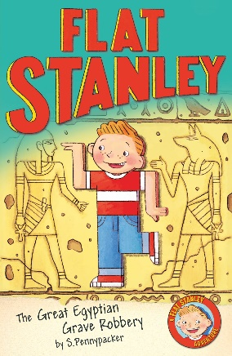  Key text
 | For support you can:  1.Ask the teacher at the end of a Zoom live learning session  2. Email ML-admin@vennacademy.org |  | If you are struggling to get connected or have lost your passwords, we can help!  Email ML-admin@vennacademy.org
Learning | English  9.15am Zoom Call | Maths  11.00am Zoom Call |  | Foundation Subjects  1.15pm Zoom call | Story Time Zoom  2:45pm Zoom Call
Monday  Date: 25th Jan 2021 | Shared Reading – read the next chapter of Flat Stanley and text mark.  English – descriptive writing | Addition and subtraction –  To add two 3-digit numbers using column addition |  | History – Why was the River Nile so important?
Tuesday  Date: 26th Jan 2021 | Shared Reading – check and discuss our text marking. Are there any words we don’t know the meaning of?  English - descriptive writing | Addition and subtraction –  Subtracting 3-digit numbers using column subtraction |  | Science – light on reflective surfaces | No Zoom
Wednesday  Date: 27th Jan 2021 | Shared Reading –  Looking  Clue  Thinking questions  English - descriptive writing | Addition and subtraction –  Subtracting 3-digit numbers using column subtraction |  | PSHE
Thursday  Date: 28th Jan 2021 | Shared Reading – predict what happens next.  English - descriptive writing | Addition and subtraction –  Solving word problems using addition and subtraction skills |  | No Zoom | No Zoom
Friday  Date: 29th Jan 2021 | Shared Reading – Let’s read a non-fiction Egyptian book and record some facts.  English - descriptive writing | Addition and subtraction –  Solving word problems using addition and subtraction skills |  | Art – focusing on light and shading when drawing a face
Additional learning throughout the week

Feel free to complete as much of your CGP learning books in all subjects. If you have questions, want help or feedback on pages you have tried alone without being set the pages please email or ask on Zoom.

Explore Purple Mash. I will keep sending 2-do’s

Log into Espresso where there a lots of videos and tutorials to find out more about what you are learning

Have you tried Youtube drawing tutorials- these guide you through a lot of cool things to draw in easy step by step guides. Have a go these are great fun!

Look at BBC Bitesize where there a lots of games and activities linked to learning. Also look at CBBC who are showing lessons and activities daily between 9.00am and 12.00pm and also through iPlayer.

Creative task! Use any medium you have available (colours, paints or if you don’t have access you can use Sketchpad 5.1 - Draw, Create, Share!) or 2create to explore the art activity.

Please take pictures and share your work on Twitter, upload to Purple Mash or email them to us at … ml-admin@vennacademy.org

Happy Learning!

