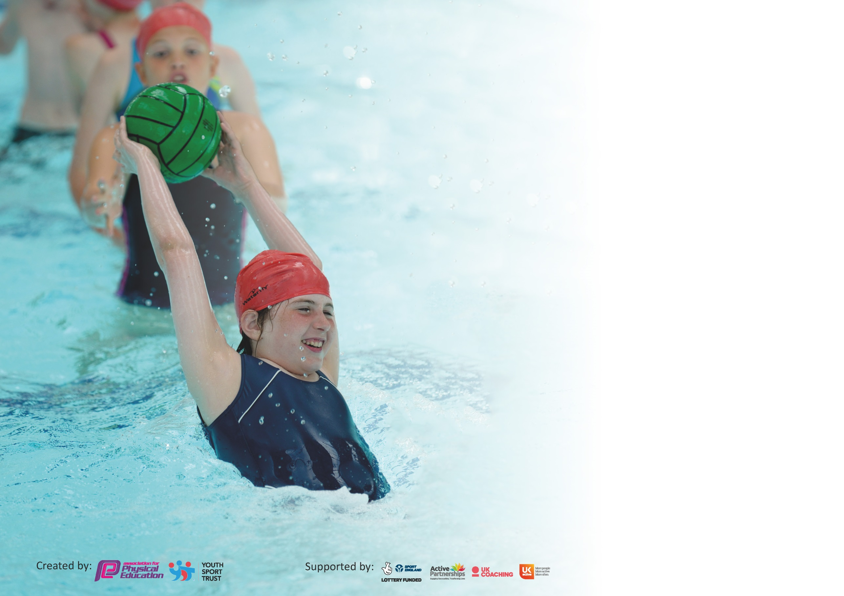

It is important that your grant is used effectively and based on school need. The Education Inspection Framework (Ofsted 2019 p64) makes clear there will be a focus on ‘whether leaders and those responsible for governors all understand their respective roles and perform these in a way that enhances the effectiveness of the school’.

Under the Quality of Education criteria (p41) inspectors consider the extent to which schools can articulate their curriculum (INTENT), construct their curriculum (IMPLEMENTATION) and demonstrate the outcomes which result (IMPACT).

To assist schools with common transferable language this template has been developed to utilise the same three headings which should make your plans easily transferable between working documents.

Schools must use the funding to make additional and sustainable improvements to the quality of Physical Education, School Sport and Physical Activity (PESSPA) they offer. This means that you should
use the Primary PE and Sport Premium to:

- Develop or add to the PESSPA activities that your school already offer
- Build capacity and capability within the school to ensure that improvements made now will benefit pupils joining the school in future years

Please visit gov.uk for the revised DfE guidance including the 5 key indicators across which schools should demonstrate an improvement. This document will help you to review your provision and to report your spend. DfE encourages schools to use this template as an effective way of meeting the reporting requirements of the Primary PE and Sport Premium.

We recommend you start by reflecting on the impact of current provision and reviewing the previous spend.

Schools are required to publish details of how they spend this funding as well as on the impact it has on pupils’ PE and sport participation and attainment by the end of the summer term or by 31st July 2020 at the latest.

We recommend regularly updating the table and publishing it on your website throughout the year. This evidences your ongoing self-evaluation of how you are using the funding to secure maximum, sustainable impact. Final copy must be posted on your website by the end of the academic year and no later than the 31st July 2020. To see an example of how to complete the table please click HERE.

Support for review and reflection - considering the 5 key indicators from DfE, what development needs are a priority for your setting and your pupils now and why? Use the space below to reflect on previous spend and key achievements and areas for development.

Key achievements to date until July 2019: | Areas for further improvement and baseline evidence of need:
- Collaboration with Club Doncaster to develop staff knowledge and increase PE opportunities for pupils within the community.  - Provision of good quality afterschool and lunch clubs.  - Equipment purchased to support new sports and activities  - Teachers delivering more PE lessons confidently.  - Silver School Games award  - Super Movers Training | - Top up swimming lessons  - Opportunities to provide parental engagement with PE  - A wider selection of sports to be offered across the school, either during curriculum time or as after school clubs. –  - Development of school teams to provide additional sporting opportunities within the community.

Meeting national curriculum requirements for swimming and water safety.
What percentage of your current Year 6 cohort swim competently, confidently and proficiently over a distance of at least 25 metres?  N.B. Even though your pupils may swim in another year please report on their attainment on leaving  primary school at the end of the summer term 2020. | 44%
What percentage of your current Year 6 cohort use a range of strokes effectively [for example, front crawl, backstroke and breaststroke]? | 71%
What percentage of your current Year 6 cohort perform safe self-rescue in different water-based situations? | 55%
Schools can choose to use the Primary PE and Sport Premium to provide additional provision for swimming but this must be for activity over and above the national curriculum requirements. Have you used it in this way? | No

Action Plan and Budget Tracking
Capture your intended annual spend against the 5 key indicators. Clarify the success criteria and evidence of impact that you intend to measure to evaluate for pupils today and for the future.

Academic Year: 2019/2020 | Total fund allocated: £17,300 | Date Updated: December 2019
Key indicator 1: The engagement of all pupils in regular physical activity – Chief Medical Officer guidelines recommend that primary school pupils undertake at least 30 minutes of physical activity a day in school |  |  |  | Percentage of total allocation:
 |  |  |  | 26%
Intent | Implementation |  | Impact
Swimming lessons for Y6 pupils who did not achieve 25 metres in Y5 | All pupils who are not able to swim 25 in Y5 will be given the opportunity to swim in Y6. | £1,465 | Did not take place due to Covid-19 and school closures.
Tracking of pupils to enable support for those less active | Purchase a scheme of work and assessment tool for tracking progress in PE. | £495 | Scheme has been bought and the teachers have planned for it from September 2020 and have received training prior to implementation.
Encourage children to be active during break and lunchtimes | Pupils to be trained as playground leaders to ensure a wide range of physical activities are available on the playground. Sporting equipment to be sourced. | £1000 | Two sets of four children became playground buddies and supported children on the playground twice a week. They were trained by leaders from Club Doncaster.
Improve learning in an afternoon with movement breaks linked to the BBC’s ‘Supermovers.’ | All children will access a physical activity using the BBC ‘Supermovers’ scheme. | nil | This was due to start April 2020 but was not implemented due to the school closure. This will be used next year.
Access physical activity sessions during breakfast club | Introduce resources and a member of staff to deliver short sessions for children during spring and summer term. | £1,500 | This was accessed twice a week before school closure.
Key indicator 2: The profile of PESSPA being raised across the school as a tool for whole school improvement |  |  |  | Percentage of total allocation:
 |  |  |  | 11%
Intent | Implementation |  | Impact
Academy to receive the Gold Mark for PE | Allocate member of staff and assess using the set criteria, continuing to provide a range of experiences.  Attend all events relevant to School Games Mark criteria. | £1,753 | Progress towards this stopped due to Covid-19 and lockdown
Raise profile of individual’s attainment in PE lessons | Children to receive PE Pupil of the Week in Celebration Assembly each week and photographs of pupils shared on social media. | Nil | This was planned for the summer term but didn’t happen due to Covid-19
Celebrate PE achievements at whole school level | Dedicated display board to raise the profile of sport and PE and use of Celebration Assembly to share team results. | £100 resources | The hall has several display boards promoting the children’s physical activities and sport and represents all the children from the Foundation Stage to the end of Key Stage 2.
Participate in the Comic Relief – ‘Sport Relief’ national day with fun sporting activities. | Supported by Club Doncaster and a visit from Donny Dog  Children participate in sporting activities during the afternoon.  Fun Zumba activities at lunch  Teachers encouraged to participate. | Nil | £200 was raised for the charity.  The majority of the teachers and Teaching assistants also took part in the Zumba dance sessions.  All children wore sporty/casual clothesThe visit from Donny Dog was very popular.

Key indicator 3: Increased confidence, knowledge and skills of all staff in teaching PE and sport |  |  |  | Percentage of total allocation:
 |  |  |  | 17%
Intent | Implementation |  | Impact
Provide CPD opportunities to develop knowledge and skills of PE coordinator | CPD opportunities through Club Doncaster, Buy Doncaster. | £288  £1,123 | Subject lead led training sessions both at Marshland and Brooke on the new PE scheme.  Subject lead was able to work with HoS to create a long term and medium term plan for PE for the whole school.
Improve quality of PE lessons | Coordinator to provide CPD sessions to upskill teaching staff. | £1200 | Club Doncaster have provided CPD through their lessons to support teachers.
Develop knowledge and skills to deliver high quality after school dance clubs | Staff members to receive CPD sessions in dance. | £245  Additional £1,500 | A member of staff was appointed as a teaching assistant but also had a dance specialism. She provided dance sessions for all children at lunch time over three days. This club has proved to be very popular.
Improve planning to ensure whole school improvement. | Leaders monitor planning and feedback will identify improvements and need for any support | nil | Club Doncaster provide plans for the PE sessions based on the needs of the children.
Up-skill PE Champion to quality assure PE lessons, sports clubs and physical activity sessions, regardless of provider. | Leaders monitor lessons and feedback will secure improvements and identify need for support. | nil | PE observations were planned for the summer term but did not take place due to school closure.
Key indicator 4: Broader experience of a range of sports and activities offered to all pupils |  |  |  | Percentage of total allocation:
 |  |  |  | 30%
Intent | Implementation |  | Impact
Provide children with opportunities for a range of clubs at different times of the day. | Organise outside providers for new/ different clubs i.e. cheerleading, etc and timetable clubs during breakfast club, lunchtime and after school. | £2,250  £1,125  £1,755 | PE put into Breakfast Club on the morning Club Doncaster is in school.  Dance Club has proved very successful at lunchtime with an average of 2/3s of each class taking part.
Enable those children taking part in the football clubs to experience a European football match at a world class venue | To organise a coach and tickets for the children attending the football clubs to go to see Man United play a European football game at Old Trafford | £750 | This was very successful and a very memorable experience for those who took part

Key indicator 5: Increased participation in competitive sport |  |  |  | Percentage of total allocation:
 |  |  |  | 13%
Intent | Implementation |  | Impact
Set up competitions across the federation and within the pyramid. | Establish links with local schools and organise timetable of key events and tournaments - release key staff to attend planned meetings | £300 | This did not occur. It was planned for in the summer term when there is better weather, but due to Covid-10 these events did not take place.
Establish academy teams linked to extra- curricular sports clubs. | Plan extra-curricular clubs across the year linked to tournament events. | £1000 | Football club was established
Raise the profile of competitive sport through appropriate kit. | Purchase sports kit for all year groups. | £1000 | Sports kit for the football team was sourced.

Signed off by
Head Teacher:
Date:
Subject Leader:
Date:
Governor:
Date:

